This post was published to Code Blog at 3:22:00 PM 1/10/2017

Installing Xamarin with Visual Studio

Category Xamarin

If you already have Visual Studio Installed on your computer, but not Xamarin, follow the steps below.

1 – Open up the Control Panel and go to thje Programs you can install (the Dow 'shelf'). Select 'Microsoft Visual Studio Enterprise 2015 with updates' and then click 'Change':

2 - You will be prompted with options, and you want to click 'Modify:

3 - When given the options of what to modify, click 'Cross platform Mobile Development' and ensure that all items below this item are checked. When you click 'Next' the system will update with the correct Xamarin tools and supporting SDKs:

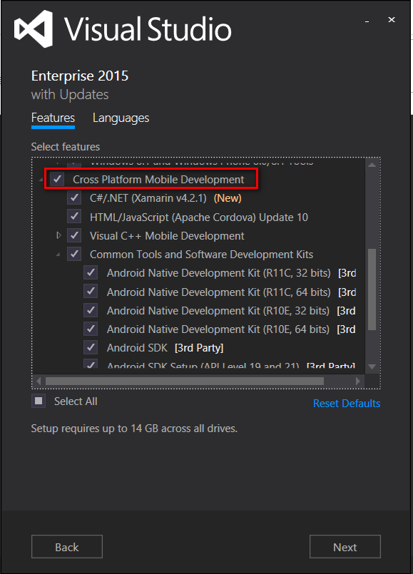

You may experience issues downloading the content (Dow Internet may block some Android items), so it may be best to go home and VPN in, and then perform the updates.

4-Install Android Studio

* <https://developer.android.com/studio/index.html#win-bundle>

5-Install Intel Haxm

* <https://software.intel.com/en-us/android/articles/intel-hardware-accelerated-execution-manager>
* You will most likely need to enable **Intel Virtualization in your BIOS** for this to install successfully
  + **You will need to temporarily disable BitLocker on your device before making this change**